

Assignment #03

Segmented Memory Model



Top of Form

1. Bottom of Form

**Segmented Memory model:-**

It is the process in which main memory of computer is divided into different segments and each segments has its own base address.

**Why we used segmented model?**

It is basically enhance the speed of execution of the computer system and the processor is able to fetch and execute the data from the memory and fast.

Model allows multiple functional windows into the main memory, a code window, a data window etc

Two main Reasons:

(a) Compatibility

(b) Memory Increase

Divide 1MB memory into segment offset pair of size 64k.Eleborate at least one segment offset pair.

**Divide 1MB memory into segment offset pair of size 64k**

A segmented memory model divides the system memory into groups of independent segments referenced by pointers located in the segment registers. Each segment is used to contain a specific type of data. One segment is used to contain instruction **codes**, another segment stores the **data** elements, and a third segment keeps the program **stack**

+-----------+

| |

| text | (fixed size)

| |

+-----------+

| |

| data | (fixed size)

| |

+-----------+

| stack | | growth

+-----------+ V

| |

| free |

| |

+-----------+ ^

| heap | | growth

+-----------+

the **offset** values are from 0000H to FFFFFH

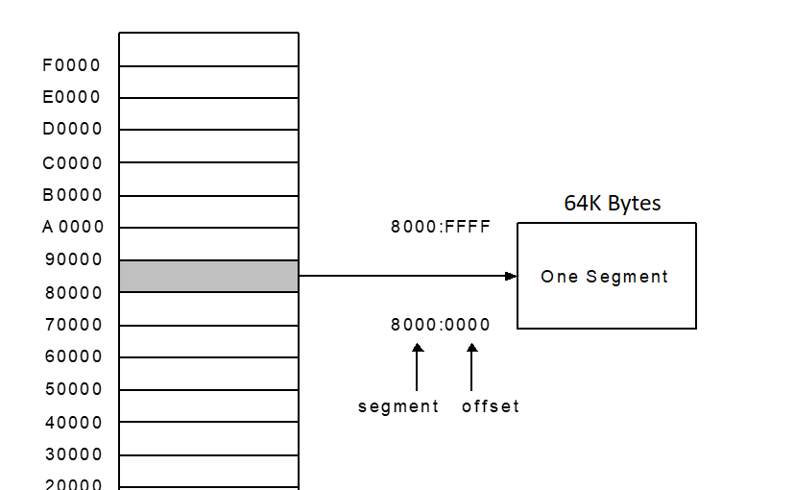

**How to find physical address**

For example

2387 (segment) : 0100(offset)

23870

+ 0100

____________

23970

Just adding the segments with offset to get the physical address.